📘 Assignment: Routers, Modems, and Switches

🔹 Task 1: Network Diagram (Router, Modem, and Switch)
Answer:
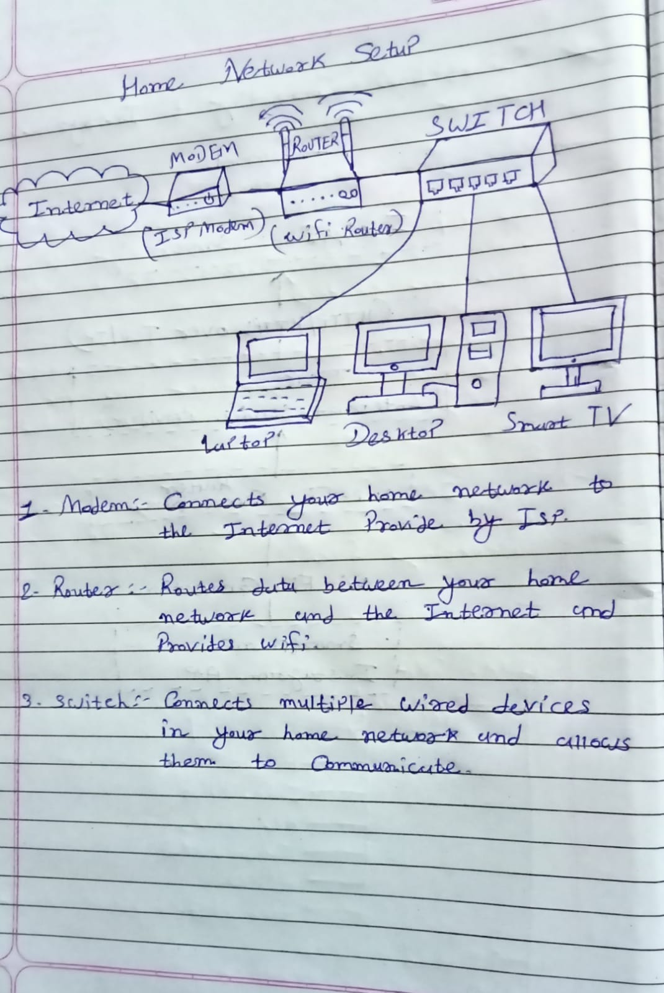
Task 2: Connected Devices on the Router
Objective: View devices connected to the Wi-Fi router.
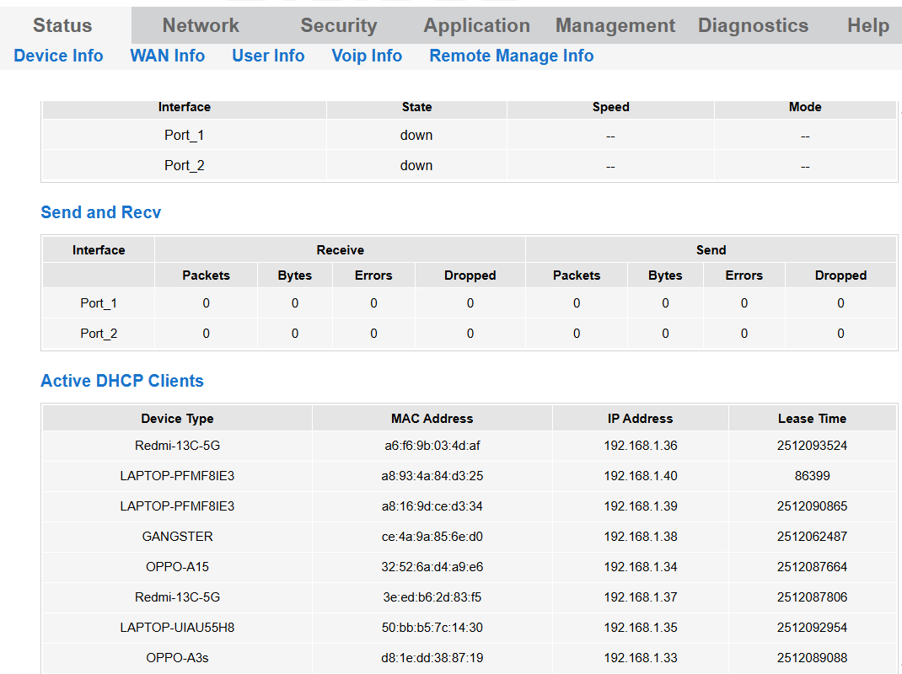

Task 3: Comparison of Router, Modem, and Switch
Feature | Router | Modem | Switch
Main Function | Connects different networks and routes internet traffic | Connects the local network to the ISP | Connects multiple devices within the same LAN
Common Usage | Home and Office | Home and Office | Mainly Office, Schools, Gaming Cafés, and Enterprise Networks
Assigns IP Addresses | Yes (using DHCP) | No | No
Supports Wi-Fi | Yes (Wireless Router) | Usually No | No
Task 4: Network Setup for a Small Gaming Café
Scenario
A gaming café has:
- 20 Gaming PCs
- 1 Printer
- Owner's Laptop
- Customers using Wi-Fi
Required Network Devices
Device | Quantity | Reason
Modem | 1 | Connects the café to the ISP for internet access.
Router | 1 | Provides internet access, DHCP, NAT, firewall protection, and Wi-Fi connectivity.
24-Port Gigabit Switch | 1 | Connects all 20 gaming PCs, printer, and other wired devices with high-speed Ethernet connections.

